**NAME---HARSH KUMAR**

**ID---B219027**

**BRANCH---CE-4TH SEM.**

**DATE--- 05-02-2021**

LAB-4

1. **UNION:** This query is used to display the combined rows of two different queries, which are having the same

structure, without duplicate rows. (should have the same columns)

**Syntax:** *SELECT field_1, field_2,....... FROM relaƟon_1 WHERE (Condition) UNION SELECT field_1, field_2,.......*

*FROM relation_2 WHERE (Condition);*

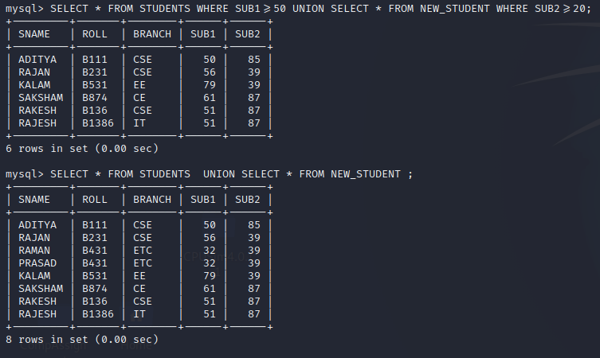

2. **INTERSET:** This query is used to display the common rows of two different queries, which are having the

same structure, and to display a selected set of fields out of them.

**Syntax:** SELECT field_1,field_2,.. FROM relaƟon_1 WHERE (CondiƟon) INTERSECT SELECT field_1,field_2,..

FROM relaƟon_2 WHERE (CondiƟon);

EXAMPLE1

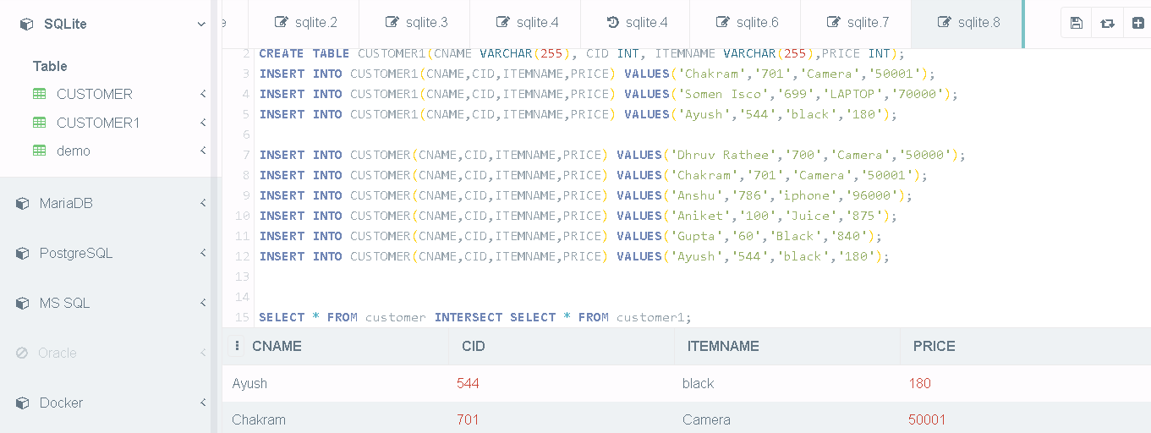

*EXAMPLE-2*

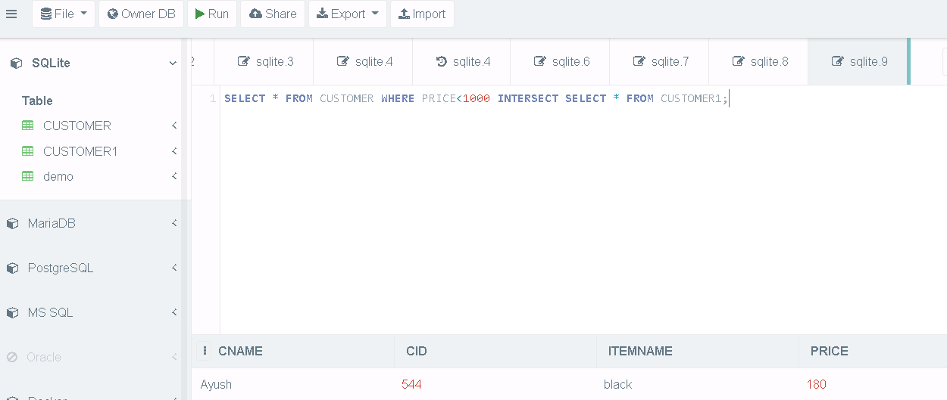

3. **UNIQUE:** The purpose of a unique key is to ensure that informaƟon in the column(s) is unique i.e. a value

entered in column(s) defined in the unique constraint must not be repeated across the column(s). A table

may have many unique keys.

**Syntax:** *CREATE TABLE Table_Name(column_name data_type(size) UNIQUE, ….);*

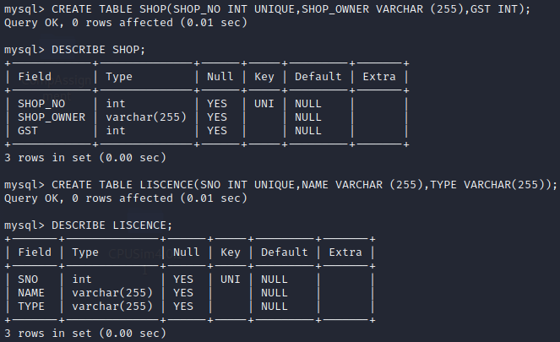

4. **PRIMARY KEY:** A field which is used to idenƟfy a record uniquely. A column or combinaƟon of columns can be

created as primary key, which can be used as a reference from other tables. A table contains primary key is

known as Master Table.

i. It must uniquely idenƟfy each record in a table.

ii. It must contain unique values.

iii. It cannot be a null field.

iv. It cannot be mulƟ port field.

v. It should contain a minimum no. of fields necessary to be called unique.

**Syntax:** *CREATE TABLE Table_Name(column_name data_type(size) PRIMARY KEY, ….);*

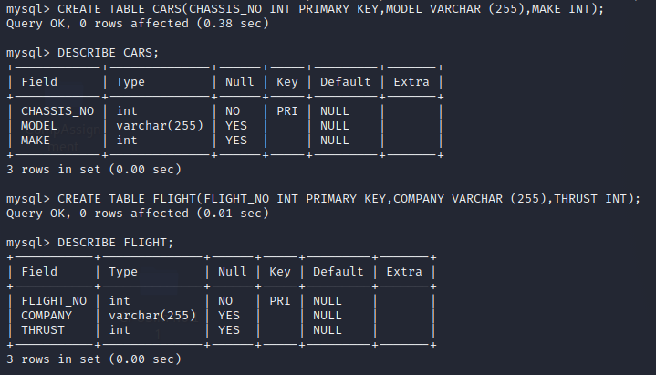

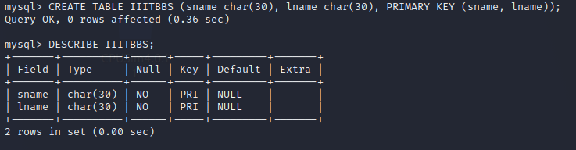

5. **AVG, MAX, MIN:** returns the Average, maximum, and minimum value of a column.

